 | 9.1.4 Editors - UV Editor - Header - Select Menu
Table of content
Select menu 2
Legacy 2
Box select 2
Circle select 2
All 2
None 2
Inverse 2
Box Select Pinned 3
Lasso Select Submenu 3
Linked 3
Linked Pick 3
Last Operator Select Linked Pick 3
Extend 3
Deselect 3
Location X / Y 3
Pinned 3
Split 3
Overlap 4
Last Operator Select Overlap 4
Extend 4
Similar 4
Pinned 4
Length 4
Length 3D 4
Area 4
Area 3D 4
Material 4
Object 4
Polygon Sides 4
Winding 4
Amount of Faces 5
Last Operator Select Similar 5
Type 5
Compare 5
Threshold 5
Shortest Path 5
Last Operator Pick Shortest Path 5
Face Stepping 5
Topology Distance 5
Fill Region 5
Nth Element 5
Skip 6
Offset 6
More / Less submenu 6
More 6
Less 6

Select menu

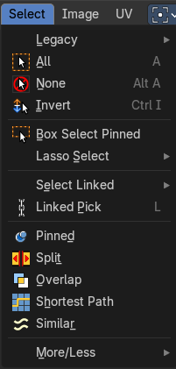
This menu just appears when you are in Mask mode. And you need to create a new mask layer to set all items active. The select functionality in this menu covers the mask geometry. The splines.

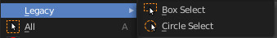
Legacy
The legacy sub menu contains tools that exists in the tool shelf already. It's the old way to do things. Different to the tools in the tool shelf, these tools are usually modal. And performs once. You have to call them again in case you want to repeat the tool.

Box select
Draw a rectangle to select everything inside of the rectangle.
It automatically adds to the current selection. Holding down shift subtracts from the selection.

Circle select
Brush select content. The radius of the brush can be adjusted by holding down left mouse button and using the scroll wheel or the + or - button at the numpad.
It automatically adds to the current selection. Holding down shift subtracts from the selection. To exit the circle select tool click with the right mouse button.

All
Select everything.

None
Select nothing.

Inverse
Invert the current selection.

Box Select Pinned
Box select enters the Border Select mode. This is a special select mode where you can select elements by dragging a rectangle. And what's inside of the rectangle gets selected then. It adds to selection by default. Box Select Pinned just selects pinned UV vertices. The other box select method can be found in the tool shelf.
To subtract from selection hold down Shift key.
The selection gets applied when you release the mouse. You leave the mode automatically when you release the mouse.

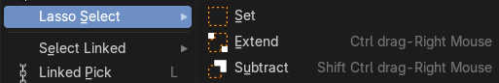
Lasso Select Submenu
The legacy lasso select tool. You can choose between three modes. Lasso select is also available in the tool shelf.

Linked
Select all UV vertices linked to the active UV map. The previous selection gets cleared.

Linked Pick
Hotkey Only Tool!
Select all UV vertices linked to the active UV map. The previous selection gets cleared.

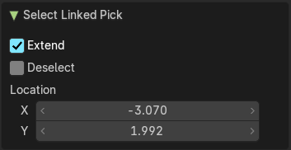
Last Operator Select Linked Pick

Extend
The previous selection gets kept, the selection gets extended.

Deselect
Deselect instead of select

Location X / Y
The mouse position in the UV space, normalized to the 0.0 to 1.0 range of the UV space.

Pinned
Select pinned UV vertices.

Split
Select only entirely selected faces.

Overlap
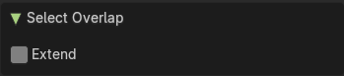
Select all UV faces that overlaps each other.

Last Operator Select Overlap

Extend
Extend the current selection.

Similar
Similar selects similar elements to the already selected parts. It is mode dependant. When you are in Vertex mode, then it shows just a Vertex related menu. When you are in edge select mode, then a edge related menu. And when you are in face select mode, then a face related menu. And this for both, the UV sync selection off and on.

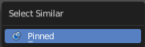
Pinned
Select UV patches with pinned vertices.

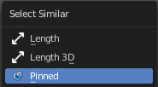
Length
Select UV edges that has the same length in the UV Space.

Length 3D
Select UV edges that has the same length in the 3D View.

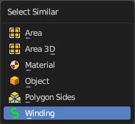
Area
Select UV edges that has the same area in the UV Space.

Area 3D
Select UV edges that has the same area in the 3D View.

Material
Select UV faces with the same material.

Object
Select UV faces at the same object.

Polygon Sides
Select UV faces that points into the same side in the 3D view.

Winding
Select UV faces in winding order.

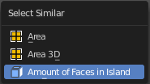
Amount of Faces
With UV Select Mode Islands. Selects all UV Islands with the same amount of faces.

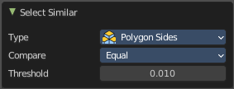
Last Operator Select Similar

Type
The select similar method.

Compare
Compare if the element to select should be greater, equal or less big than the current selection.

Threshold
A tolerance setting.

Shortest Path
Select the shortest path between two selected elements.
Note that shortest path is a hotkey tool. Select the first element, hold down ctrl, select the second element.

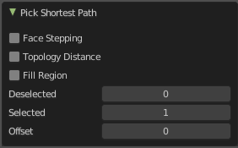
Last Operator Pick Shortest Path

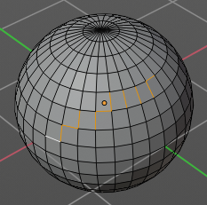
Face Stepping
Traverse connected faces.

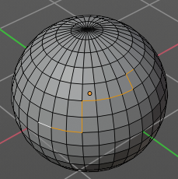
Topology Distance
Find the minimum number of steps instead of the shortest distance.

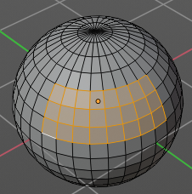
Fill Region
Select the region faces too.

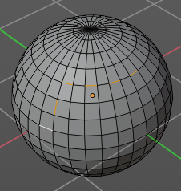
Nth Element
Don't select the whole path, but just every nth element of it.

Skip
This is connected to nth element. Number of elements to skip at once.

Offset
This is connected to nth element. Start with an offset.

More / Less submenu

More
Grow the selection.

Less
Shrink the selection.

